PART-C Questions
UNIT-I
1. (i) Explain the concept of Artificial Intelligence and Intelligent Agents.
(6 Marks)
(ii) Discuss the types and key characteristics of intelligent agents.
(6 Marks)

2. Explain the characteristics and types of AI task environments with suitable examples.

3. Describe in detail the different types of Intelligent agents with a neat block diagram and pseudo-code.

4. i) Explain how Bidirectional Search works and write its pseudo code. (8 Marks)
ii) List the benefits and disadvantages of Bidirectional Search. (4 Marks)

5. Explain the Depth-First Search (DFS) algorithm in detail. How does it function as an uninformed search strategy? Apply DFS to traverse the given state space graph with ‘A’ as Start Node and ‘G’ as Goal Node, and show the step-by-step expansion of nodes.
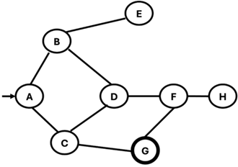

6. Describe the core principles of Depth-Limited Search (DLS) and Iterative Deepening Depth-First Search (IDDFS). Provide the standard pseudocode for the DLS recursive function, clearly explaining the role of its parameters. Furthermore, explain the key problem that IDDFS solves compared to a standard Depth-First Search.
a) The state space graph below has A as its start node and G as the goal node. The connections and costs between nodes are defined in the associated diagram.
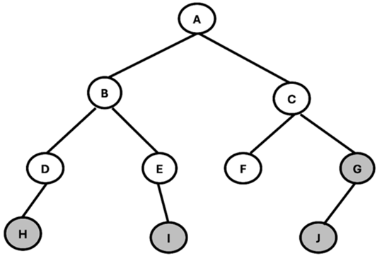

b) Apply the Iterative Deepening Search algorithm to this graph.
i) Show the sequence of node expansions for each iterative depth level (beginning at depth 0) until the goal node G is found.
ii) For each depth level, state the limit and list the order of nodes visited.
iii) Report the final solution path from A to G discovered by IDS.

7. Apply BFS and DFS to the following State Space Graph after constructing a Search Tree, Where S is the Initial Node, and G is the Goal Node.
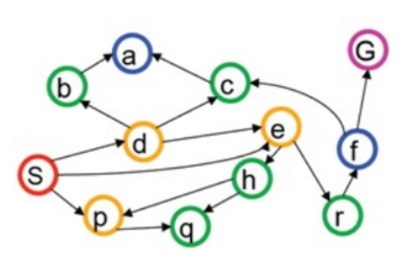

8. i) Develop a Python program to implement an AI agent for the vacuum-cleaner world. (5 Marks)
ii) Solve the Water Jug Problem:
You are given two jugs one with a capacity of 4 gallons and the other with 3 gallons. There are no measurement markings on either jug. A pump is available to fill the jugs with water.
Using the following assumptions:
· A jug can be filled completely from the pump.
· Water can be emptied onto the ground.
· Water can be poured from one jug to the other until either the source jug is empty or the destination jug is full.
· No other measuring devices are available.
Explain how you can obtain exactly 2 gallons of water in the 4-gallon jug.
(7 Marks)

9. Apply BFS and DFS to the following State Space Graph after constructing a Search Tree Where A is the Initial Node and H is the Goal Node.
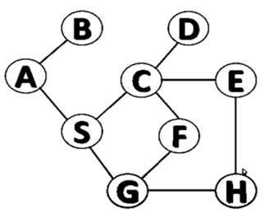

10. (i) Give PEAS Representation for the following real world agents. (6 Marks)
(a) Medical Diagnose
(b) Vacuum Cleaner
(c) Part picking Robot
(ii) Explain the Uniform-cost Search Algorithm with an example.

UNIT-II

1. Solve the Travelling Salesman Problem (TSP) for salesman visiting 5 cities using the Branch and Bound method.
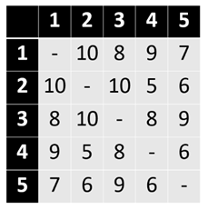
Given the travel cost matrix, determine the least-cost Hamiltonian circuit.

2. i) Develop a Python program for Monte Carlo Tree Search (MCTS) in a non-deterministic environment. (6 Marks)
ii) Write a pseudo-code for an online search agent that learns the environment while navigating using heuristic functions. (6 Marks)

3. i) Implement the A* algorithm and explain how it uses a heuristic function to find the optimal path. (6 Marks)
ii) Discuss the properties and admissibility of the A* algorithm. (6 Marks)

4. i) Describe the Steepest-Ascent Hill Climbing technique and discuss its limitations along with a remedy. (6 Marks)
ii) Distinguish between local and global search methods with appropriate examples. (6 Marks)

5. i) Explain the A* search algorithm and write the pseudo code. (6 Marks)
ii) Apply the A* algorithm to find the optimal path in the given State Space Graph (S → G). (6 Marks)
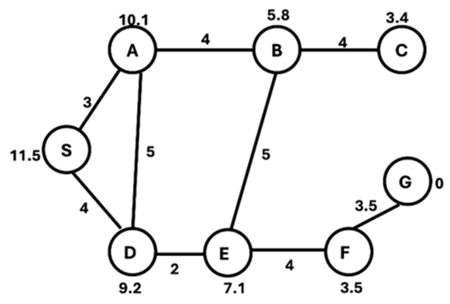

6. Perform A* search for the following 8-puzzle problem
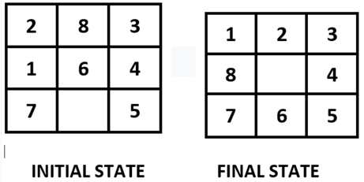

7. Suppose you have the following search space.
a) Draw the state space for this problem.
b) Assume that the Initial state is A and the goal state is G. Show how various Best First search algorithms would create a search tree to find a path from the initial state to reach the goal state:
STATE | NEXT | COST
A | B | 4
A | C | 1
B | D | 3
B | E | 8
C | C | 0
C | D | 2
C | F | 6
D | C | 2
D | E | 4
E | G | 2
F | G | 8
Heuristics:
STATE | H(N)
A | 8
B | 8
C | 6
D | 5
E | 1
F | 4
G | 0

8. i) What are local search and optimization problems? Explain how local search operates in continuous state spaces. (6 Marks)
ii) Compare Simulated Annealing and Genetic Algorithms in terms of exploration, exploitation, and convergence behavior. (6 Marks)

9. Consider the search problem shown in the figure below. The heuristic value h(n) for each node is provided in the accompanying table.
Using the Greedy Best-First Search algorithm, traverse the search space by selecting the node with the lowest heuristic value at each step, where the evaluation function is: f(n)=h(n)
Show the order in which the nodes are expanded and determine the path from the start node to the goal node.
Node | H(n)
A | 12
B | 4
C | 7
D | 3
E | 8
F | 2
H | 4
I | 9
S | 13
G | 0
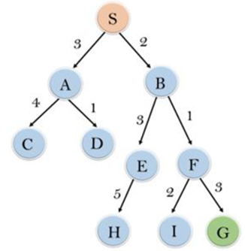

10. Explain:
(i) Local Search in Continuous Spaces. (6 Marks)
(ii) Search with Nondeterministic Actions. (6 Marks)

